

Cloud Computing Assignment #1 Spring 2018

Sri Devi Mallipudi

16251191

**Task: Prepare a simple web page (html file) with your name on it. (Use any tools or even just MS-word and save it as a html file) and deploy the web page on GENI.**

1. Create one VM (Virtual Machine) and reserve the resources.

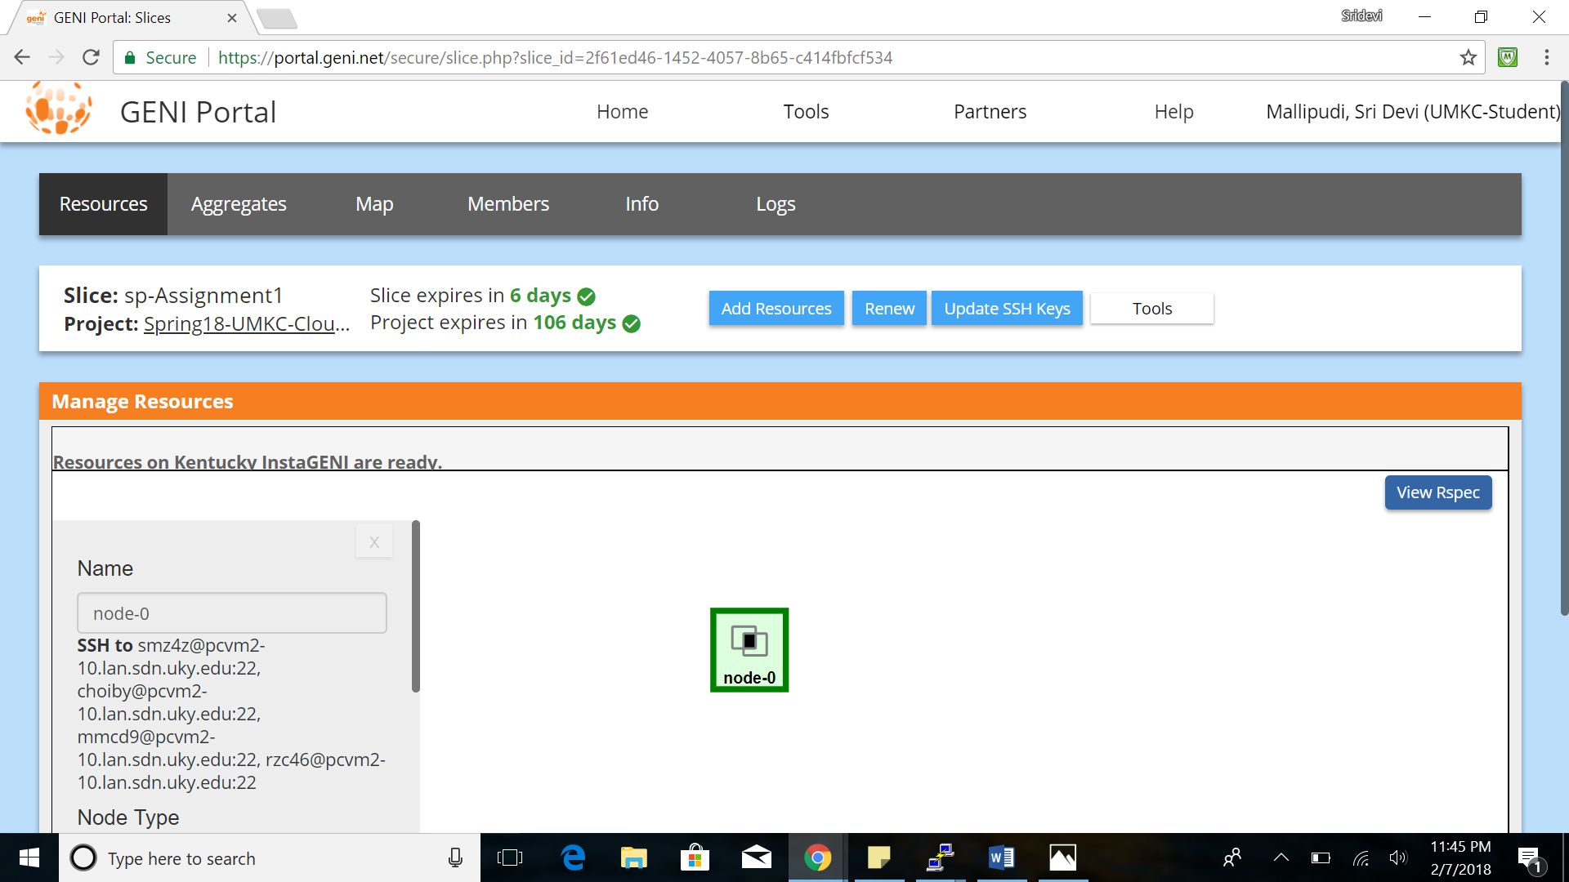

1. Enable the node using PUTTY with generated SSH key

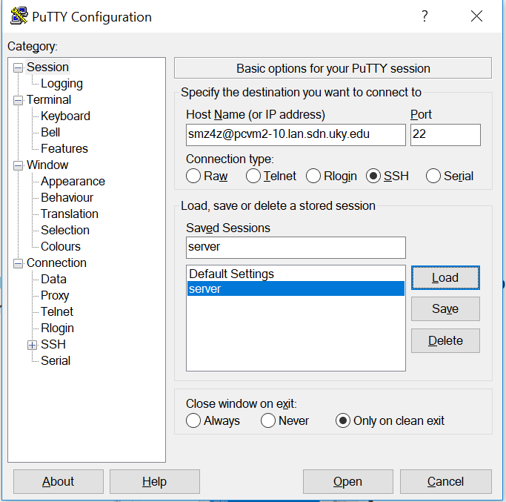

1. Create a simple html file and deployed the web page on GENI

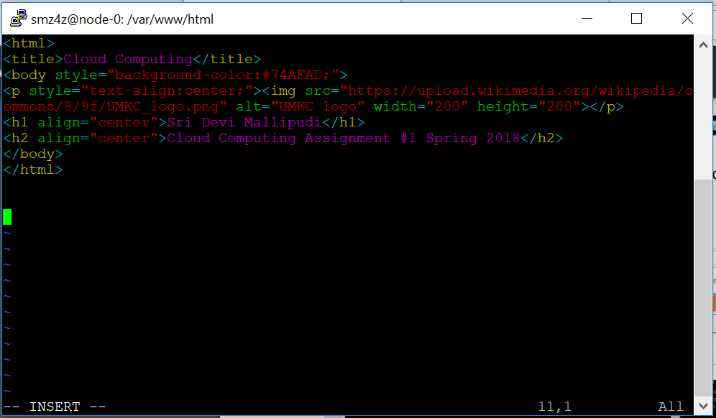

1. When the client sends a request for the contents from a local browser with this IP address **128.163.232.68**, then the server shows the web page.

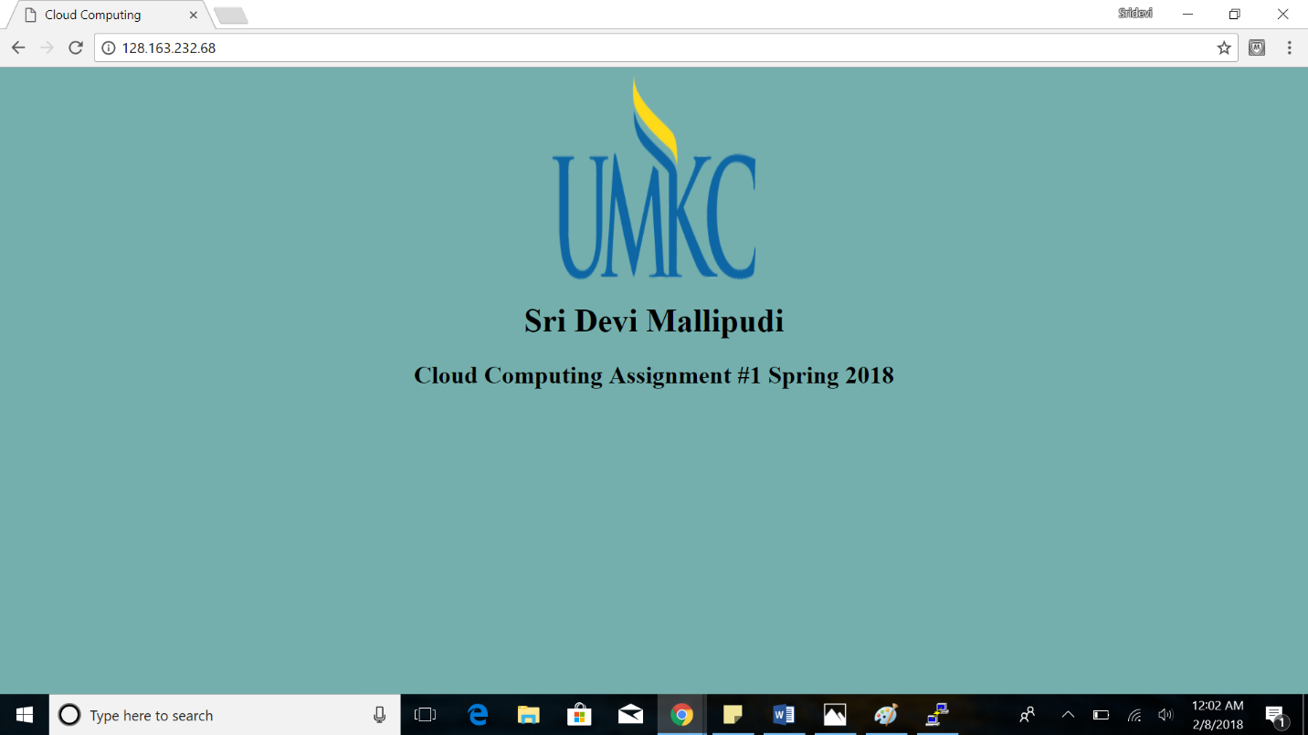

**EPILOGUE:**

With this assignment I am able to learn the concepts of deploying the webpages on server and had the opportunity to practically implement them.

For me the difficult part in the assignment is that I was not able to host the webpage on the browser. But each time when I got an error or couldn’t move on I had gone through many documents in online to solve the issue. This made me to learn about many concepts which are new to me.

**Link to the website** - http://128.163.232.68/